Tipuri de date
“Planuri” pt tipuri de date => Abstracte / Algebraice
- Structura tipului de date
- Operatii specificie tipului
- Proprietati ale tipului

Nat (numere naturale)
- Structura
0 => zero; 1 => Succ(zero); 2 => Succ(Succ(Zero))
Zero: Nat <-|
Succ: Nat -> Nat <-| constructori

- Operatii
isZero: Nat -> Boolean <- axiome
isZero(zero) = true
isZero(Succ(n)) = false ∀ n ∈ Nat <- axiome

add: Nat x Nat -> Nat
add(Zero, n) = n
add(Succ(m), n) = Succ(add(m,n))

(>) greater: Nat x Nat -> Boolean
greater(Succ(n), Zero) = True
greater(Zero, n) = False
greater(Succ(n), Succ(m)) = greater(n, m)
3 > 2 if 2 > 1 if 1 > 0 => True

- Proprietati
Add(n, add(m, p)) = add(add(n, m), p)
greater(Succ(n), n) = True

Case classes vs classes
- Objects instanced using case classes are immutable
- The members of a case class are immutable as well
- The comparision of two onjects instanced using case class is done structurally not referencially (it checks if they’re built the same ig)
- A case class has a single constructor
- Match (check how n is constructed)

IList
|x:Int | xs:Int|
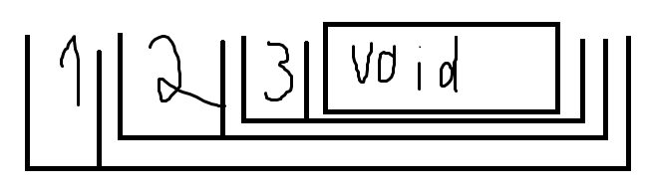
^ ^
head tail
for 1 2 3 =>

